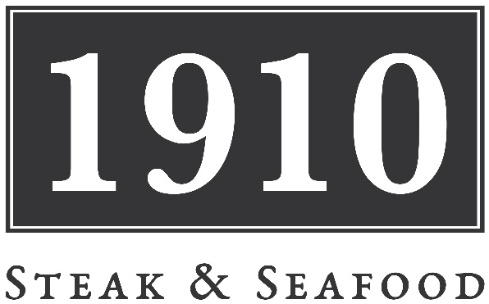

**1910 x The Lord Crewe***Thursday 23rd October 2025*

**£65.00 per person**

*Presented by Stephan Thomas, Former Head Chef of The Crab & Lobster, Asenby, North Yorkshire and  
current Head Chef of The Lord Crewe Bamburgh.*

*Featuring your favourite dishes from The Crab and The Lord Crewe, this is the perfect event for Steak & Seafood lovers. Highlights include the famous Crab & Lobster Goats Cheese Tart,   
Grilled Queenie Scallops, Grand Reserve Sirloin and Posh Fish & Chips.*

**On Arrival**

Spicy BBQ Sausages

Fresh Bread Selection; Wholemeal, Cheese & Tomato, The Crab’s ‘Fruit Bread’

**Starters**

Grilled Queenie Scallops, Roast Shallots, Garlic & Almond Herb Butter,

Mature Cheddar, Gruyere Cheese, Fresh Breadcrumbs

The Crab’s Prawn Cocktail, Prawns, Creamed Avocado,

Bloody Mary Jelly, Iceberg, Single Malt Marie Rose, Whitby Crab Spring Roll

The Crab’s Pork Spare Rib’s – Sticky Orange & Ginger Sauce

Classic Chunky Fish Soup, Garlic Croutons, Gruyere Cheese, Rouille

Thin Tart of Local Goat’s Cheese, Confit Red Onion, Beetroot, Baby Leaf, Dijon & Honey Ice Cream

Moules Marinière – Shetland Mussels, White Wine Cream, Garlic & Parsley

**Main Courses**

The Crab’s Posh Fish & Chips – Battered Cod, Roast King Scallop, Crushed Garden Peas, Swordfish,  
Oak Roast Salmon, ‘Posh’ Tartare Sauce, Chips, Lemon

Grilled Prime Aged Grand Reserve Sirloin Steak, Roast Onion & Chorizo Crust, Red Wine Jus,   
Hand Cut Chips, Baby Leaf

Twice Baked Wensleydale Soufflé, Candied Walnuts, Celery Pesto, Baby Leaf, Skinny Fries

Half Classic Lobster Thermidor – Lobster, King Prawns, Queenie Scallops, New Potatoes, Watercress, Lemon

Pan Fried Halibut Loin, Whitby Crab Crust, Wilted Greens, Crab & Lobster Bisque

Pan Roasted Fillet of Stone Bass, Charred Aioli Potatoes, Summer Broth of Mussels, Cockles,   
Prawns, Vegetables & Sea Asparagus

**Desserts**

Whipped Cappuccino Crème Brûlée, Chocolate Shards

“A Mess” - Yorkshire Strawberries, Crushed Meringue, Whipped Cream, Raspberry Ice Cream

Sticky Date, Apricot & Stem Ginger Pudding Toffee Sauce, Vanilla Ice Cream, Jug of Cream

Baked Blueberry Cheesecake, Fresh Blueberries, Mint, Vanilla Ice Cream

Apricot & Croissant Pudding, Warm Custard

Selection of Yorkshire Cheeses, Artisan Crackers, Chutney, Grapes